First State Corvette Club of Delaware
Cruises 17 Corvettes into Rock Hall
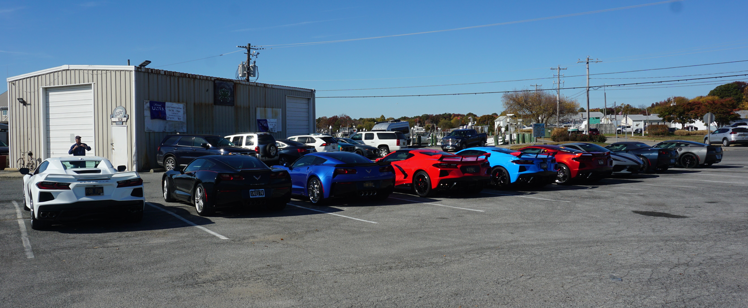
The First State Corvette Club(FSCC) of Delaware had seventeen Corvettes and 32 members
venture on a Monthly Mystery Cruise through Maryland andDelaware back roads ending at Waterman’s
Crab House in Rock Hall with mystery solved.This particular FSCC Monthly Mystery Cruise was organized by club members Betty Ann and J.J. Johnson with the help of Marianne Callahan, First State Corvette Club President. Tiffany Lauman, Waterman’s General Manager and her staff couldn’t have been friendlier or more efficient. Many members of Waterman’s staff came out to greet the corvettes as they arrived, taking numerous photos. The event turned out to be a great road trip and introduction to experiencing Rock Hall, underscoring the motto “Nice People Live Here!”

Courtesy Tidewater Trader
Submitted photo

